Responsible Agriculture Investment (RAI) Tool Report Template

This template should be used in conjunction with the Guidance provided for the use of the RAI Tool, especially Section 5.

General Considerations and Recommendations for Writing the RAI Tool Report
Language | This report is written first and foremost for the agribusiness’s management. It should initially be written in the primary formal language used for business operations and internal reporting within the agribusiness.  After the report has been vetted internally, it can be translated into English, French, or another relevant language(s), allowing the results to be shared more easily among other stakeholders, such as investors and partner organisations.
Organisation | The report should be punchy and well structured, to facilitate clarity and fast reading.
Pictures and graphics | Text should be supplemented with pictures and graphics to support arguments, provide examples, and improve readability. Pictures of farmers and the agribusiness staff give the reader a glimpse of reality on the ground.
Length | We recommend making it a summary report, not a detailed, lengthy document! Focus on the most important information. The reader wants a quick overview of the agribusiness’s results.
Audience | Remember the different people who will read the summary report (investors, agriculture experts, practitioners, networks, technical assistance providers, the general public) and tailor your prose so that it is suitable.

Strategy for Communication of Results
- Ask the agribusiness management to review and validate the report. If needed and pertinent, revise the report accordingly after communicating with the management.
- Encourage the agribusiness to disseminate the report to, among others,
- internal stakeholders: board of directors, staff, farmer suppliers, clients
- external stakeholders: investors, donors, technical assistance providers, partner organisations, parent organisations.
- Suggest a process to the management whereby the proposed action plan can be discussed, evaluated, modified, and ultimately implemented. Potentially, other stakeholders could be involved in this process.

Note:
The underlined areas in the template below are where inputs are to be provided. The text explains what is required and how to use the information entered.

Responsible Agriculture Investment (RAI) Performance of [Name of the agribusiness]
[Country, Month Year]
1.0 Introduction
Briefly introduce the agribusiness (name, country of operation, sector of activity, type of agricultural product, role in the value chain, etc., as relevant) and present the reasons for applying the RAI Tool, as well as the assessment method (self-assessment, external assessment, etc.).
The RAI assessment of the agribusiness was conducted using the RAI Tool, a reference tool that allows agribusinesses to assess whether their policies, practices, procedures, and operations are aligned with best practices of responsible business conduct in the agriculture and food sectors (in compliance with international standards such as the CFS-RAI Principles and IFC Performance Standards). The RAI Tool assesses an agribusiness’s strengths and weaknesses on responsible business conduct, with the goal of using this information to help the agribusiness improve its relevant management systems and practices over time.
If deemed relevant, more details on the RAI Tool can be added: how the tool is structured, how filters are applied, how scores are computed, etc. These details can be found in the “RAI Tool Guidance – When and how to use the tool.”
This report summarises the findings of the RAI assessment, conducted by name from DATE to DATE.
[Feel free to add pictures of the agribusiness’ operations and staff, farmers, and other stakeholders]

Description of the Agribusiness
Provide a brief description of the agribusiness’ profile, context, and history, giving details not contained in the “Introduction” above, including
- general information: year of creation, legal status, nature of business, mission statement, areas of operations, number of staff, etc.
- business model: products, target market, number of farmer suppliers, key partners, affiliations or parent organisation, certifications, etc.
- challenges and opportunities faced.
Provide some economic and industry context. This will help contextualise the conditions under which the agribusiness operates, as well opportunities and constraints in developing and implementing an action plan.
[Feel free to add some graphs to facilitate understanding the business and its context.]

2.0 Key RAI Results <Month Year>

Overall RAI Results
Provide a brief introduction and overview of the agribusiness’s RAI performance, before the detailed section by dimension. Does the agribusiness perform well overall? What can explain this global performance? What are the agribusiness’s key strengths? Use the overall results in the dashboard as pertinent.
[Insert the agribusiness’ RAI Tool dashboard – example below.]
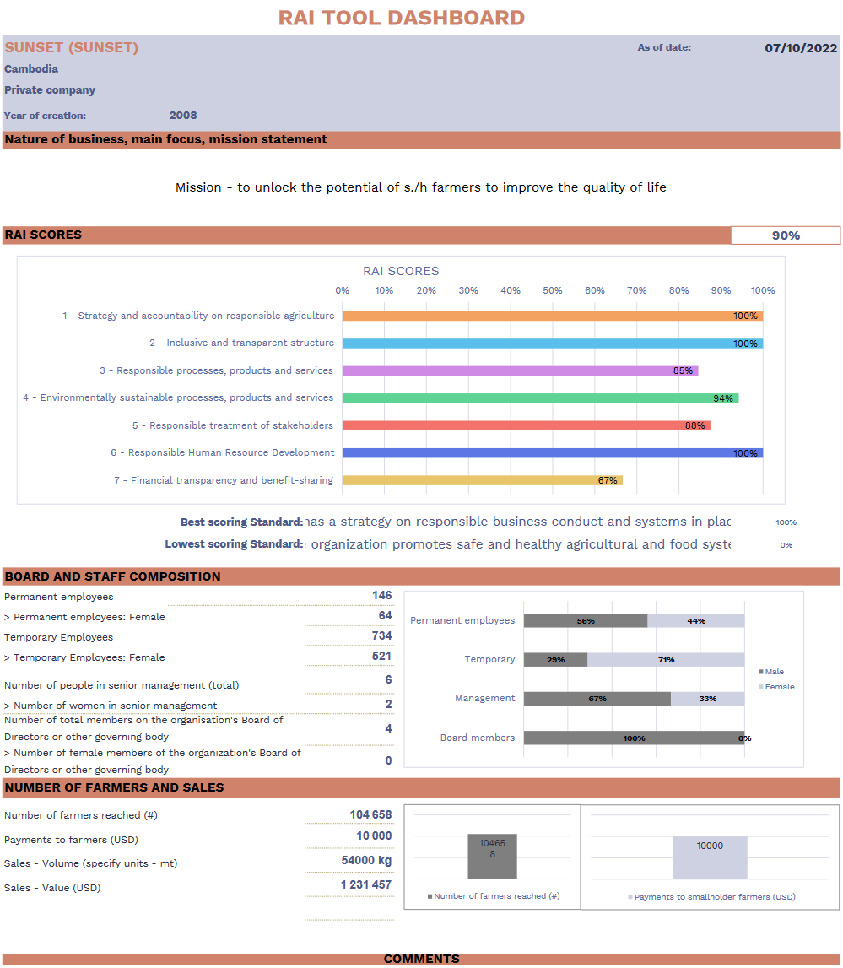
3.0 RAI Results by Dimension

Dimension 1
Strategy and Accountability on Responsible Agriculture (Average score for dimension = XX%)
Aligned with:
- CFS-RAI Principle 10 “Assess and address impacts and promote accountability”
- IFC Performance Standard 1 “Assessment and Management of Environmental and Social Risks and Impacts”
A documented strategy, with specific goals, indicators, and targets, provides a framework for implementing well-considered, relevant, consistent actions for responsible business conduct. Dimension 1 lays out key practices to specify and implement a strategy on responsible business conduct and to assess and manage environmental and social risks and impacts.
<Picture>
You may also want to include a quote from agribusiness staff, farmers or other stakeholders or provide details on an example of good practice.

Summarise the agribusiness’s activities and efforts to date in addressing the two standards in Dimension 1.
Start with the positive results, i.e., those standards on which the agribusiness obtained a good score, moving to poorer scores. Mention special efforts or particular circumstances that explain why the agribusiness obtained these results and if there are any initiatives pending whose implementation will influence this score in the near future. (Examining detailed evidence and information provided in the practices section of the tool is insightful.) Conclude with recommendations and areas of improvement, i.e., in those standards (and essential practices) in which the agribusiness did not obtain a good score. Either address each of the standards in separate paragraphs or summarise the whole dimension in one paragraph.
[insert the agribusiness’s graph results for Dimension 1 – example below.]
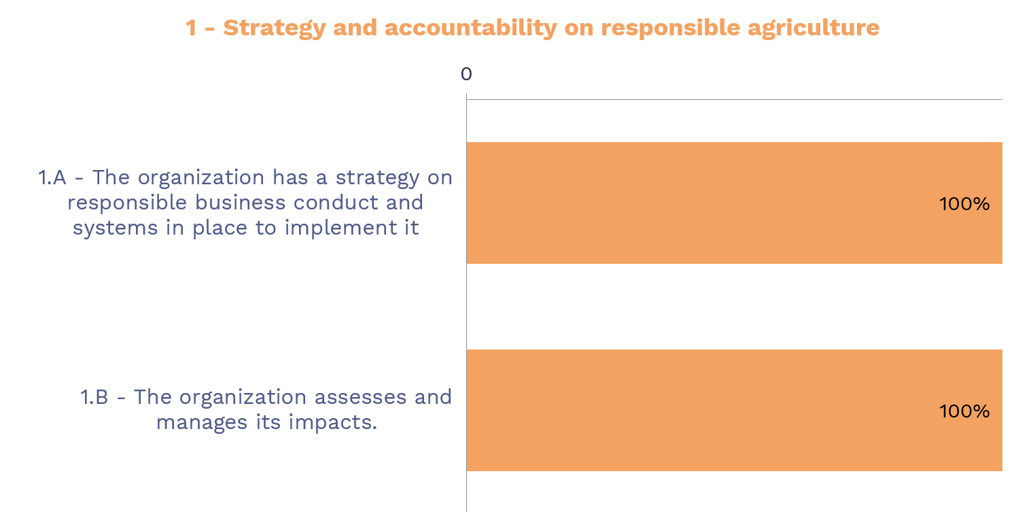

Dimension 2
Inclusive and Transparent Structure (XX%)
Aligned with:
- CFS-RAI Principle 9 “Incorporate inclusive and transparent governance structures, processes, and grievance mechanisms”
- IFC Performance Standard 1 “Assessment and Management of Environmental and Social Risks and Impacts”
Inclusiveness and transparency in business are the basis for trust and good long-term relationships between a company and its stakeholders. Dimension 2 examines key practices to ensure transparent communication, stakeholder consultation, and effective grievance resolution mechanisms.

<Picture>
You may also want to include a quote from agribusiness staff, farmers, or other stakeholders or provide details on an example of good practice.
Summarise the agribusiness’s activities and efforts according to the three standards in Dimension 2.
Start with the positive results, i.e., those standards on which the agribusiness obtained a good score. Mention special efforts or particular circumstances that explain why the agribusiness obtained these results and if there are any initiatives pending whose implementation will influence this score in the near future. (Examining detailed evidence and information provided in the practices section of the tool is insightful.) Conclude with recommendations and areas of improvement, i.e., in those standards (and essential practices) in which the agribusiness did not obtain a good score. Either address each of the standards in separate paragraphs or summarise the whole dimension in one paragraph.
[insert the agribusiness’s graph results for Dimension 2 – example below.]
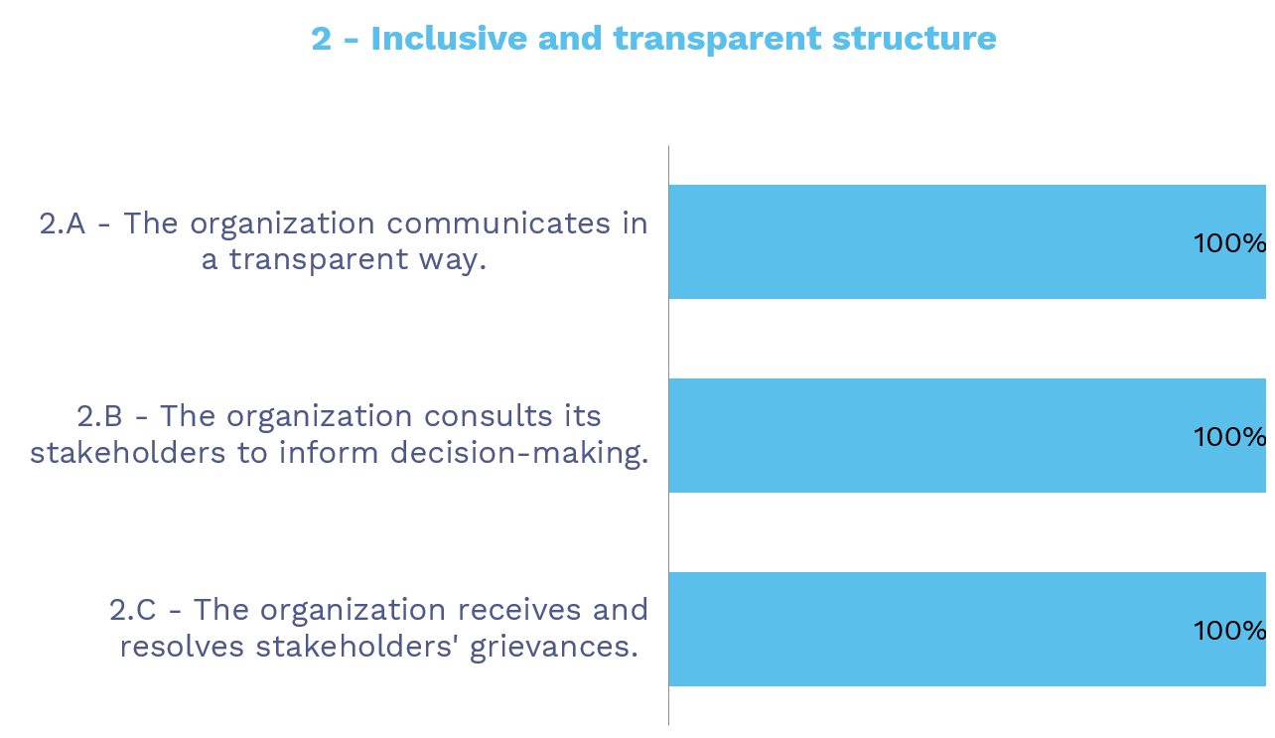

Dimension 3
Safe and Responsible Agriculture and Food Systems and Operations (XX%)
Aligned with:
- CFS-RAI Principle 1 “Contribute to food security and nutrition”
- CFS-RAI Principle 8 “Promote safe and healthy agriculture and food systems”
Having safe and responsible systems and operations in agriculture and food systems has two aspects: (a) contributing to food security and nutrition, in particular for local communities, and (b) ensuring food safety. Dimension 3 specifies key practices to ensure an agricultural production process that will strengthen agricultural value chains, improve food security and nutrition for local communities, and promote safe and healthy food products.
<Picture>
You may also want to include a quote from agribusiness staff, farmers, or other stakeholders or provide details on an example of good practice.
Summarise the agribusiness’ activities and efforts according to the two standards in Dimension 3.
Start with the positive results, i.e., those standards on which the agribusiness obtained a good score. Mention special efforts or particular circumstances that explain why the agribusiness obtained these results and if there are any initiatives pending whose implementation will influence this score in the near future. (Examining detailed evidence and information provided in the practices section of the tool is insightful.) Conclude with recommendations and areas of improvement, i.e., in those standards (and essential practices) in which the agribusiness did not obtain a good score. Either address each of the standards in separate paragraphs or summarise the whole dimension in one paragraph.
[insert the agribusiness’s graph results for Dimension 3 – example below.]
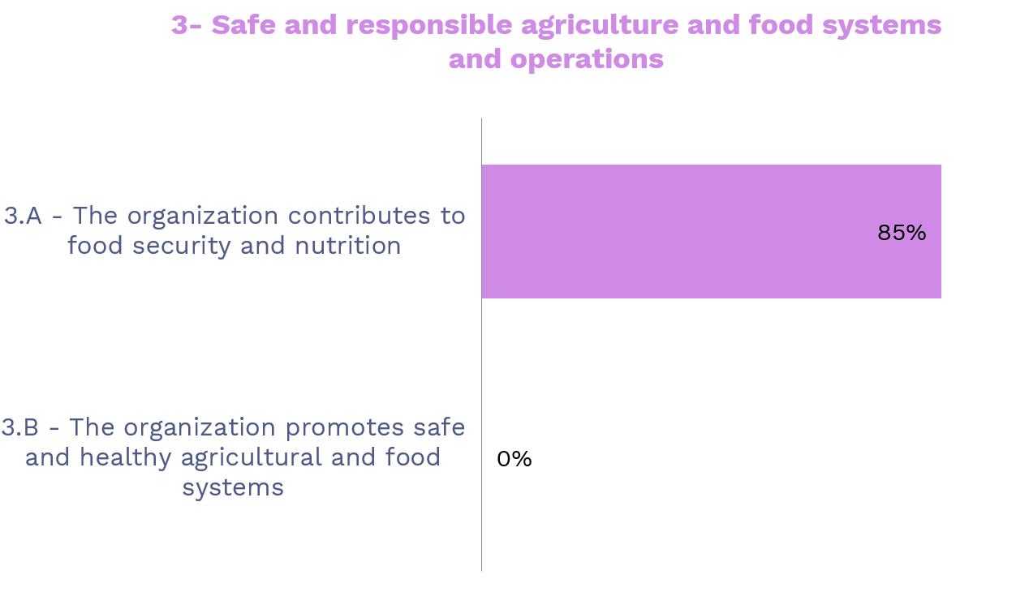

Dimension 4
Environmentally Sustainable Processes and Products (XX%)
Aligned with:
- CFS-RAI Principle 6 “Conserve and sustainably manage natural resources, increase resilience, and reduce disaster risks”
- IFC Performance Standard 3 “Resource efficiency and pollution prevention”
- IFC Performance Standard 6 “Biodiversity conservation and sustainable management of living natural resources”
Environmental issues are of particular concern in the agricultural sector, as (a) inadequate practices can directly generate adverse impacts on the environment (deforestation, land degradation, use of toxic chemicals, exhaustion of natural resources, etc.), and (b) agricultural production is itself directly and seriously affected by climate change and environmental degradation, with smallholder farmers bearing the brunt of this impact. Dimension 4 examines key practices to ensure the responsible management of environmental risks and the promotion of environmentally sustainable practices.

<Picture>
You may also want to include a quote from agribusiness staff, farmers or other stakeholders or provide details on an example of good practice

Summarise the agribusiness’ activities and efforts according to the two standards in Dimension 4.
Start with the positive results, i.e., those standards on which the agribusiness obtained a good score. Mention special efforts or particular circumstances that explain why the agribusiness obtained these results and if there are any initiatives pending whose implementation will influence this score in the near future. (Examining detailed evidence and information provided in the practices section of the tool is insightful.) Conclude with recommendations and areas of improvement, i.e., in those standards (and essential practices) in which the agribusiness did not obtain a good score. Either address each of the standards in separate paragraphs or summarise the whole dimension in one paragraph.
[insert the agribusiness’s graph results for Dimension 4 – example below.]
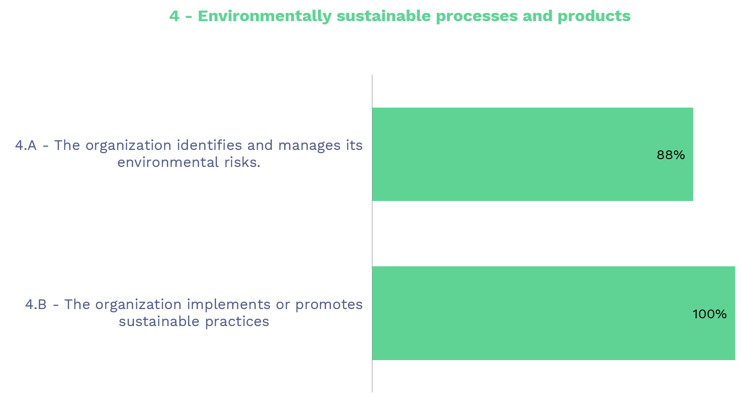

Dimension 5
Responsible Treatment of Stakeholders (XX%)
Aligned with:
- CFS-RAI Principle 5 “Respect tenure of land, fisheries, and forests, and access to water”
- CFS-RAI Principle 7 “Respect cultural heritage and traditional knowledge, and support diversity and innovation”
- CFS-RAI Principle 2 “Contribute to sustainable and inclusive economic development and the eradication of poverty”
- IFC Performance Standard 5 “Land acquisition and involuntary resettlement”
- IFC Performance Standard 7 “Indigenous People”
- IFC Performance Standard 8 “Cultural Heritage”
Agribusinesses interact with a variety of stakeholders, and the power balance between an agribusiness and smallholder farmers or local communities usually favours the company. This is why it is critical that an agribusiness puts in place policies, procedures, and practices to ensure responsible treatment of all stakeholders, in particular the most vulnerable ones. Dimension 5 examines key practices encouraging respect for legitimate tenure rights on land, fisheries and water, cultural heritage, and traditional knowledge, and ensuring responsible and fair contracting.
<Picture of farmers>
You may want to include a quote from one of the farmers or other stakeholders, or provide details on an example of good practice.
Summarise the agribusiness’s activities and efforts according to the three standards in Dimension 5.
Start with the positive results, i.e., those standards on which the agribusiness obtained a good score. Mention special efforts or particular circumstances that explain why the agribusiness obtained these results and if there are any initiatives pending whose implementation will influence this score in the near future. (Examining detailed evidence and information provided in the practices section of the tool is insightful.) Conclude with recommendations and areas of improvement, i.e., in those standards (and essential practices) in which the agribusiness did not obtain a good score. Either address each of the standards in separate paragraphs or summarise the whole dimension in one paragraph.
[insert the agribusiness’s graph results for Dimension 5 – example below.]
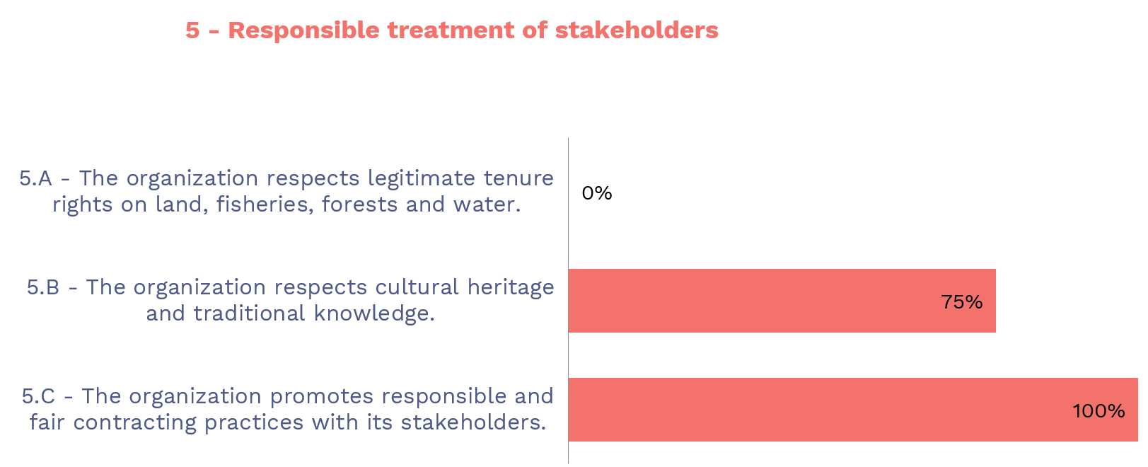

Dimension 6
Responsible Human Resource Development (XX%)
Aligned with:
- CFS-RAI Principle 2 “Contribute to sustainable and inclusive development and the eradication of poverty”
- CFS-RAI Principle 3 “Foster gender equality and women’s empowerment”
- CFS-RAI Principle 4 “Engage and empower youth”
- IFC Performance Standard 2 “Labor and Working Conditions”
Staff are the greatest asset of any company. Actively valuing your staff, ensuring that their roles and responsibilities are clear, and listening to their ideas about how to improve an organisation motivates them and improves performance and productivity. Responsible treatment of employees is critical to a successful agribusiness. Employees who are well-treated in accordance with their rights are more likely to perform and treat other stakeholders responsibly. Dimension 6 lays out key practices to create a safe and equitable work environment, attract and maintain a qualified and motivated workforce, and ensure that human resource systems support an organisation’s strategy on responsible business conduct.

<Picture>
You may want to include a quote from agribusiness staff, farmers, or other stakeholders or provide details on an example of good practice.
Summarise the agribusiness’ activities and efforts according to the three standards in Dimension 6.
Start with the positive results, i.e., those standards on which the agribusiness obtained a good score. Mention special efforts or particular circumstances that explain why the agribusiness obtained these results and if there are any initiatives pending whose implementation will influence this score in the near future. (Examining detailed evidence and information provided in the practices section of the tool is insightful.) Conclude with recommendations and areas of improvement, i.e., in those standards (and essential practices) in which the agribusiness did not obtain a good score. Either address each of the standards in separate paragraphs or summarise the whole dimension in one paragraph.
[insert the agribusiness’s graph results for Dimension 6 – example below.]
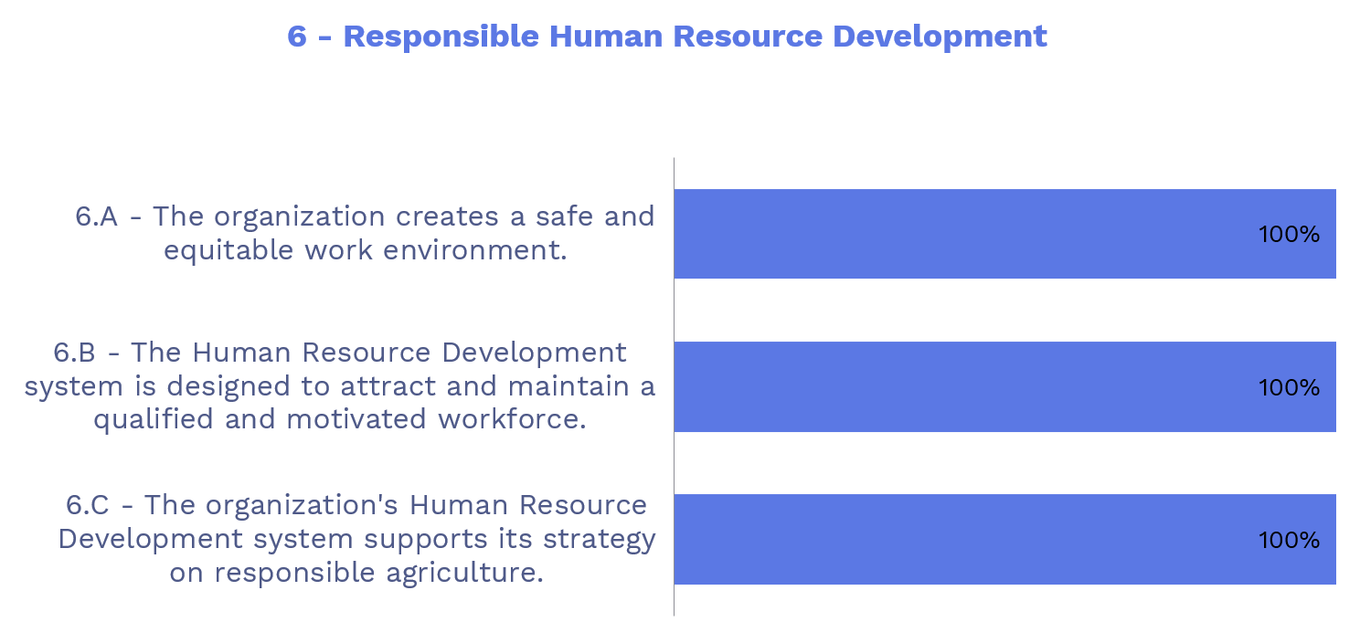

Dimension 7
Financial Transparency and Benefit Sharing (XX%)
Aligned with:
- CFS-RAI Principle 2 “Contribute to sustainable and inclusive development and the eradication of poverty”
- CFS-RAI Principle 3 “Foster gender equality and women’s empowerment”
- CFS-RAI Principle 4 “Engage and empower youth”
Dimension 7’s standards start from the premise that an agribusiness’s financial decisions and results should also reflect its commitment to responsible business conduct. Dimension 7 lays out key practices for a transparent financial structure and responsible use of profits.
<Picture>
You may want to include a quote from agribusiness staff, farmers, or other stakeholders or provide details on an example of good practice.
Summarise the agribusiness’s activities and efforts according to the two standards in Dimension 7.
Start with the positive results, i.e., those standards on which the agribusiness obtained a good score. Mention special efforts or particular circumstances that explain why the agribusiness obtained these results and if there are any initiatives pending whose implementation will influence this score in the near future. (Examining detailed evidence and information provided in the practices section of the tool is insightful.) Conclude with recommendations and areas of improvement, i.e., in those standards (and essential practices) in which the agribusiness did not obtain a good score. Either address each of the standards in separate paragraphs or summarise the whole dimension in one paragraph.
[insert the agribusiness’s graph results for Dimension 7 – example below.]
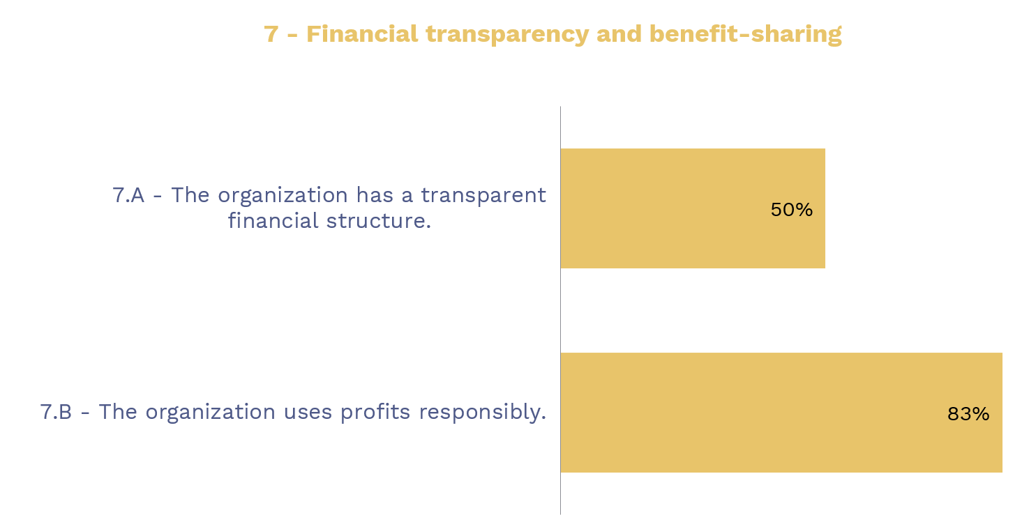

4.0 Conclusion and Recommendations
Summarise by emphasising the agribusiness’s main strengths and identifying two or three (not more!) key areas for responsible business conduct improvement. Propose very concrete steps and actions for the agribusiness, addressing these key issues, that could serve as the basis for an improved RAI focus on its next business plan. These should be the top two/three priority issues as seen by the auditor, taking into account the results of the RAI Tool, the organisation’s mission and strategic priorities, and their available budget for improvements.
It may also be useful to consider the wider context: e.g., proposed changes might be restricted or difficult to implement because of a challenging business environment or government restrictions. This could lead to recommendations to other stakeholders, e.g., the government or investors in the agribusiness.

Action Plan Proposal
Using your knowledge of the results of the RAI Tool, the salient issues in the local context, the organisation’s strategic priorities, and the organisation’s willingness and ability to allocate budget toward responsible business conduct improvements, the auditors should develop an action plan for the agribusiness that lists all the main areas of improvement. These follow-up actions should be prioritised in order of importance/feasibility, beginning with those areas that would be very important to address and not too expensive to fix. This action plan should be vetted with the organisation’s senior management, ideally in order to obtain buy-in for and approval of addressing the highest priority items in the next budgetary cycle.

Appendix - Assessment methodology
Provide a brief description of the methodology applied: who conducted the assessment (internal/external); what sources of information; what interviews were conducted, with which stakeholders, and how (online, in the field…); were the preliminary results discussed with the agribusiness, etc.

